# Lab Exercise 9: Manipulating Data

Consider you will have this following table in your database:

# WALLET (WALLET_ID, WALLET_NAME, WALLET_PRICE, WALLET_MATERIAL, WALLET_COLOUR)

1. Consider this following data to be inserted into WALLET table:

|  |  |  |  |  |
| --- | --- | --- | --- | --- |
| **WALLET_ID** | **WALLET_NAME** | **WALLET_PRICE** | **WALLET_VENDOR** | **WALLET_COLOUR** |
| 246 | Mystic | 500 | Fossils | Red |
| 247 | Turbo | 200 | Coaches | Violet |
| 248 | Chill | 700 | LVV | Orange |
| 249 | Profess | 550 | Handyglove | Green |

* 1. Insert the first row of data without specifying the columns in the INSERT clause



* 1. Insert the second row of data and explicitly specify the columns in the INSERT clause



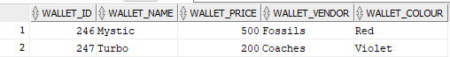

1. Modify your SQL in 1(a) and prompt the user to give an input for data to be inserted in WALLET table.

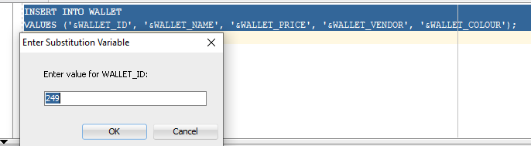

1. Make the changes of your SQL in 2 permanents.



1. Change the name for Turbo to become slow.

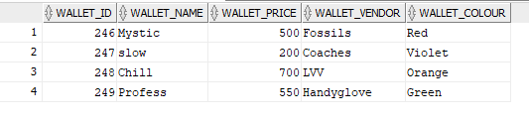

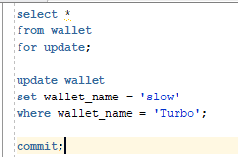

1. Change the colour to Green for all the models in Red colour.

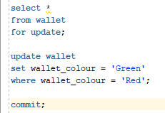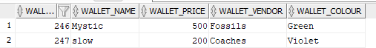

1. Delete Profess from the database.

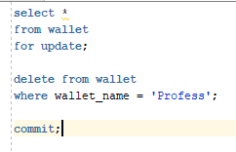

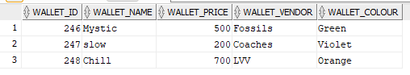

1. Without using commit, save the changes you’ve made in 6.

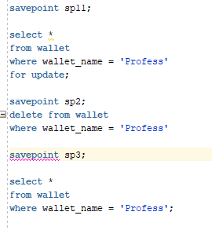

1. Delete all the rows from WALLET table.



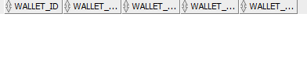

1. Retrieve back the data that you have deleted in 8.



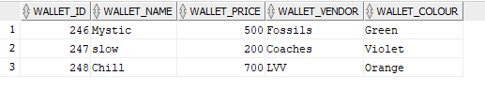

1. Make the changes permanent.

